Here is our Fundraising Goal and Milestones: 240k at 4mill Valuation Cap.

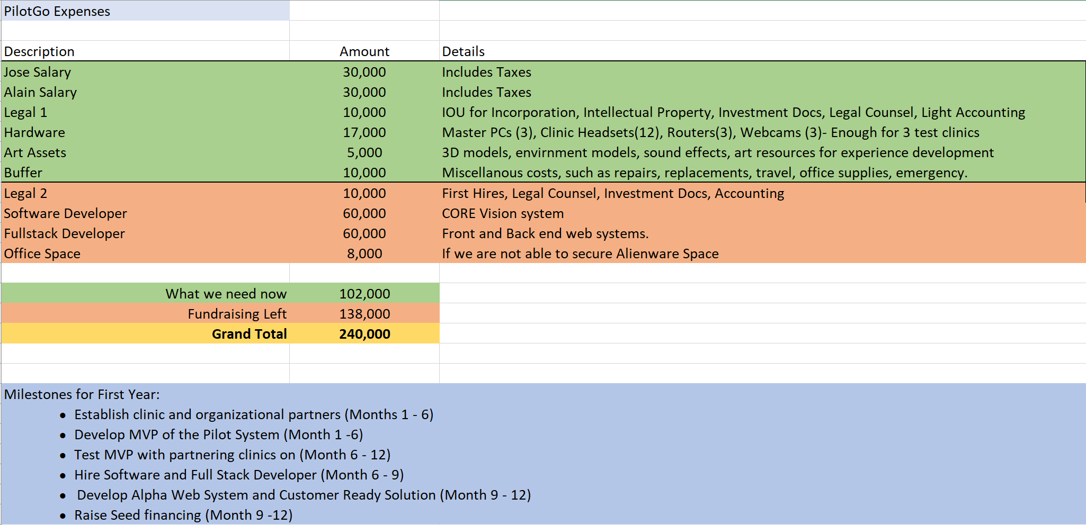

Here is the executive summary:

PilotGo is a healthcare technology company that believes in empowering people through experiences. Physical Therapy clinics are having trouble capturing value due to decreasing reimbursement rates. This forces their therapists to treat more patients per day, reducing the quality of the care and increasing expenses. PilotGo allows PT clinics to reduce the cost of treating a patient by empowering the therapist to quickly deliver personalized treatments while maintaining high quality standards.

Problem:

Physical Therapy Clinics are finding it increasingly difficult to **capture Value** and **deliver Quality Care** with current business model, which is represented by:

**(Number of Patients * Average Reimbursement Rate) – Operational Expenses = Value**

The problem is driven by the following factors:

* **Average Reimbursement Rates** by insurance aregoing down, meaning that **Value** proportionally decreases. We can’t control this variable.
* Clinics arelooking for solutions to recover lost **Value** in two ways. When attempting to increase **Number of Patients**, proportional growth in **Operational Expenses** follow. When attempting to reduce **Operational Expenses**, **Number of Patients** proportionally decreases.In both instances, clinics also experience a decrease in **Quality of Care**.
* Patient disengagement, frustration and boredom with current PT practices lead a lack ofcompliance**,** which negatively impacts **Quality of Care** and **Value.**

Based on this analysis, we concluded that a clinic must **increase Number of Patients** ***WITHOUT* proportionally increasing** **Operational Expenses** ***AND* increase** **Quality Care to** **maximize Value**. Decreasing **Operational Expenses** without proportionally decreasing **Number of Patients** is not scalable and does not maximize **Value**. So how can we achieve this?

Solution:

To solve the problem, we concluded that we must **increase a Physical Therapist’s efficiency at delivering quality treatment.** This means that for the same **Operational Expense**, a Physical Therapist can treat an increased **Number of Patients** and capture more **Value**.

To achieve this, we have developed **a prototype** and are building a **proprietary Virtual Reality platform** that seamlessly connects Therapists and Patients, accurately tracks Patient motion and facilitates the delivery of Physical Therapy session experiences. Here’s how it would work:

* Therapists diagnoses the patient, assigns first set of virtual exercises as a session through our platform.
* Patient logs into our platform, sees assigned virtual exercises in session and performs them through interactive/engaging games and experiences.
* Our system tracks patients body and checks if exercises are being performed correctly, guides patient though motions, while it collects motion data from the session.
* Once finished, our platform compiles that motion data.
* Therapist now logs into our platform, check patient performance through compiled session motion data. Assigns new exercise sessions based on data presented.
* Go to step 2.

Resulting in:

* Empowering Clinics by maximizing **Value**.
* Empowering Physical Therapists by facilitating interactions and **Quality Care** delivery.
* Empowering Patients by engaging them in an immersive recovery process.

What we Need:

We are currently seeking **“Pre-Seed”** money of around 240k for a 12 month runway with the following goals:

* Establish clinic and organizational partners
* Develop MVP of the Pilot System in Q1 and Q2 of this year.
* Test MVP with partnering clinics on Q3
* Raise Seed financing in Q4